Q. Demonstrate DNS server in packet Tracer.
Aim:- To demonstrate DNS server in packet Tracer. Setup:
- One Pcs,One Switch C One server.
- Connect Pcs to switch and switch to server. (3).Then in server on the DNS services.
- Then origin ip address and DNS server .
- For Pc also origin ip address and DNS server ip of the server.

Topology:

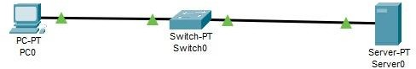

Config:
(1).Go to HTTP in server.
- There in file name index make some changes.
- Save it and then in DNS service add the name for the website and the DNS server and add that detail.
- Now go to Pc in there desktop click web browser and put the name of the file in URL and click go.
- If the topology work successfully then the website will be displayed.

Verification: In PCs Command Prompt. PC0:
C:\ipconfig
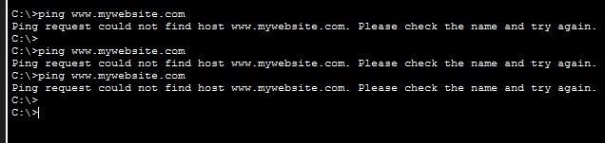
C:\ping www.mywebsite.com

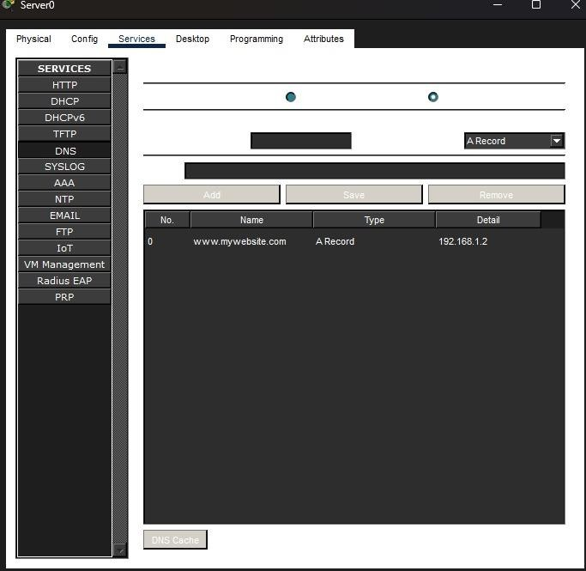

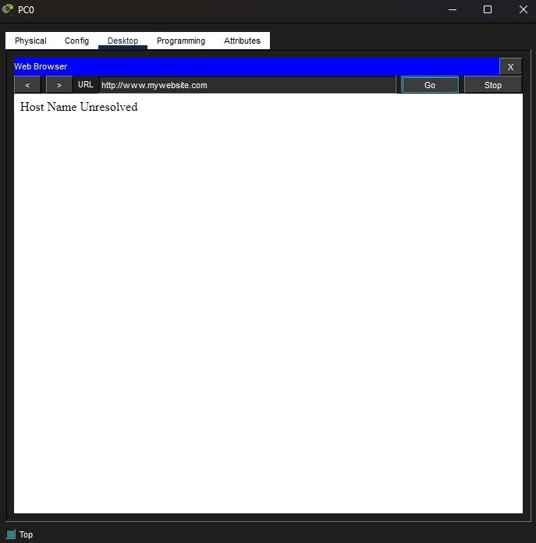

Conclusion:The above Topology has been executed successfully.

